1. **Problem Statement:**

The case study involves a Coffee Vending Machine. There is a display for the user to select the beverage. Once the user selects the beverage the buttons near to the display, Coffee beans are ground and mixed with boiled water. These are then poured to cup of the customer with required quantity of milk. Used coffee grounds are disposed to the waste tray which should be manually removed. There is a mechanism to regulate the temperature of water so that it is kept at the safe temperature limit. Also, it is made sure that temperature does not fall below minimum temperature. There is a mechanism to monitor the quantity of milk and coffee and in case of shortage, it will be shown on the display. When the waste trays are full, it will also be prompted on the display. There is also mechanism to monitor the quantity of water, coffee and milk mixed and to be poured to the cup.

* A coffee vending machine has a set of buttons to select beverage and a set of lights next to the button for displaying the selection
* There is a display for showing the selection made using the switch, indicated if Milk or coffee beans are empty or to display whether there is any error.
* A boiler to heat water just below boiling point which is regulated by a temperature control system
* A mixing chamber to mix coffee and hot water to brew
* A sensor to release correct amount of boiled water to mixing chamber
* A grinder to grind the coffee beans
* A sensor to release correct amount of milk to water
* A mechanism to release the coffee
* Waste tray to collect ground coffee beans after usage
* Sensor for monitoring milk and coffee available in storage

Input/Output –

* Pressing a button while coffee vending machine is inactive will change it to active state
* Lights near to buttons are controlled by switch near to it
* These lights are turned off when the task user selects is completed
* While machine is active, selecting a button does not trigger any service

**2. Requirement Model**

**a. Use Case Diagram-**

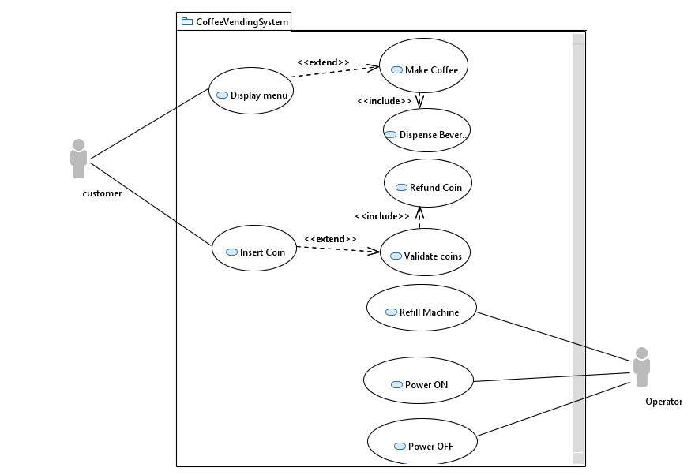

**b. Use Case Model-**

**Insert Coin and Select Beverage use case**

Use Case Name: Select Beverage

Summary: User selects which beverage they want

Actor: Customer

Precondition: Coffee Vending Machine is Idle and is displaying a welcome message

Description:

1. User deposits coins in the machine. The sensor for coin input will send signal to system to identify the coin inserted.
2. If coin inserted is proper, the system will prompt the customer to select the beverage through display.
3. User then selects the beverage he wants through the button at the front of the machine,

* Latte
* Cappuccino
* Expresso

Alternative:

1. The coin inserted by the User is not proper, the coin is rejected and given back to the user.
2. The user is prompted again to insert the coin.

Postcondition:

The Customer selects Beverage, or the coin is given back in the case where it is not proper.

**Deliver the Beverage Use case**

Use Case Name: Deliver the beverage

Summary: Deliver the beverage once the user makes a valid selection of Beverage

Actor: System

Precondition: User inserts coin and selects a beverage using the buttons in front of the coffee vending machine.

Description:

1. Once the beverage is selected by user, Coffee beans are ground by the grinder and moves to mixing chamber
2. Hot water flows from the boiler to mixing chamber where they stay some time for coffee to brew
3. The brewed coffee and milk are poured to the cup placed in front of machine alternatively so that they get mixed
4. The residue moves to Waste tray kept at the bottom of the machine.

Post Condition:

The beverage is poured into the cup of the Customer.

1. **Analysis Model**

**3.1 Analysis Static Model**

**a. Class Diagram**



**b. System Context Model –**

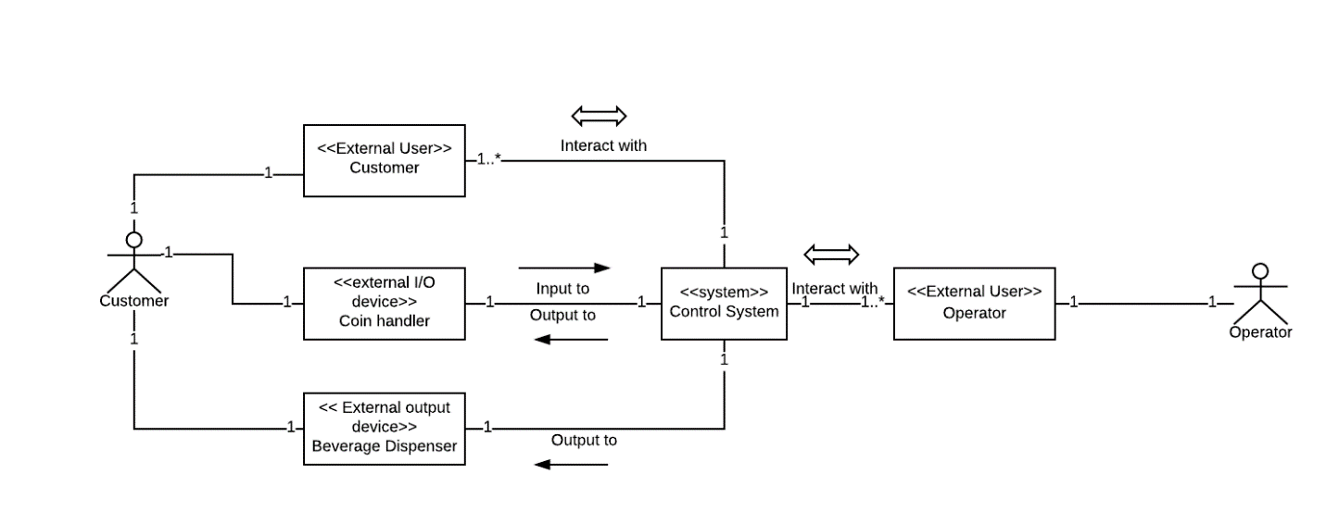

**c. Entity Class Diagram-**

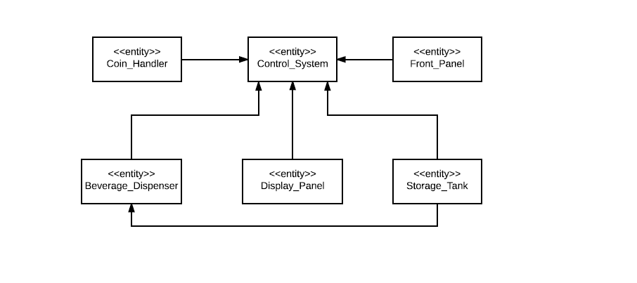

**d. Boundary Object –**

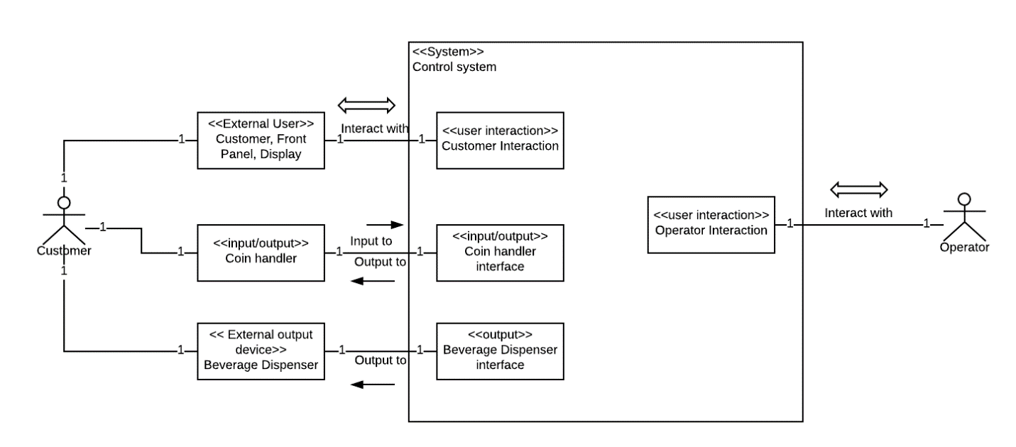

**e. SubSystems-**

The subsystems as part of the system are Coin handler, Beverage dispenser and Control system.

Coin handler : Accepts coin input validates it and dispenses change if any.

Beverage Dispenser : Makes and Dispenses beverage

Control System : Controls and monitors all subsystems and deals with user interaction.

**3.2 Analysis Dynamic Model**

**a. Classes-**

Customer : The one who want to buy the coffee. He can Interact with the system using Front Panel, Display and Coin Handler.

Front_Panel :Provided with Buttons so that customer can make selections.

Display_Panel : To show the status of Control System to Customer.

Coin_handler : To accept the coin from the customer and to dispense change.

Control_system : Controls and coordinates different parts of the system.

Beverage_Dispenser : Inorder to dispense beverage to customer after it is made.

Storage_tank : To store milk used to make the beverage.

**b. Sequence Diagram-**

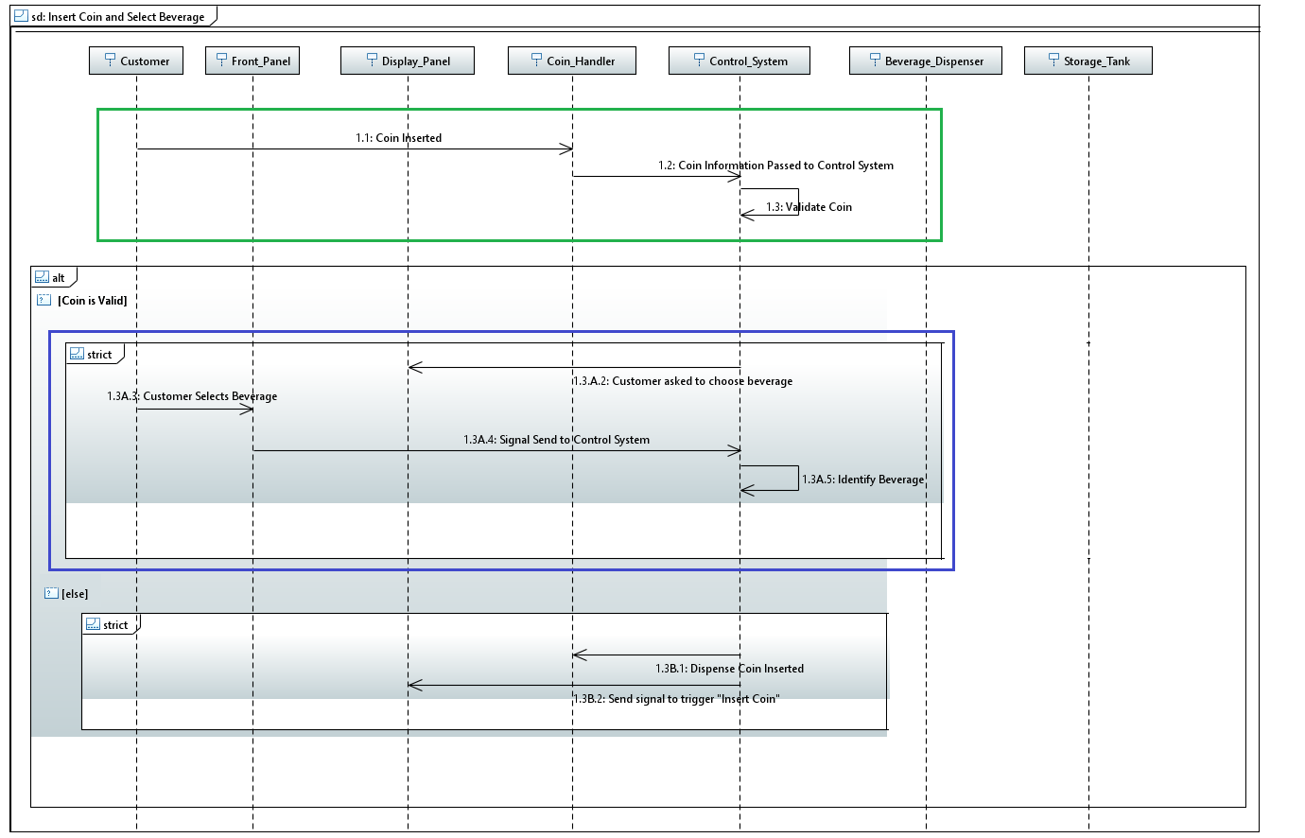

The Sequence diagram for insert coin and select beverage is shown above. Once user deposit coins in the machine, the sensor of coin handler will identify the coin inserted. If coin inserted is proper, the system will prompt the customer to select the beverage through display. User then selects the beverage he wants through the button at the front of the machine. The happy path for insert coin is marked with green in the sequence diagram and select beverage with blue.

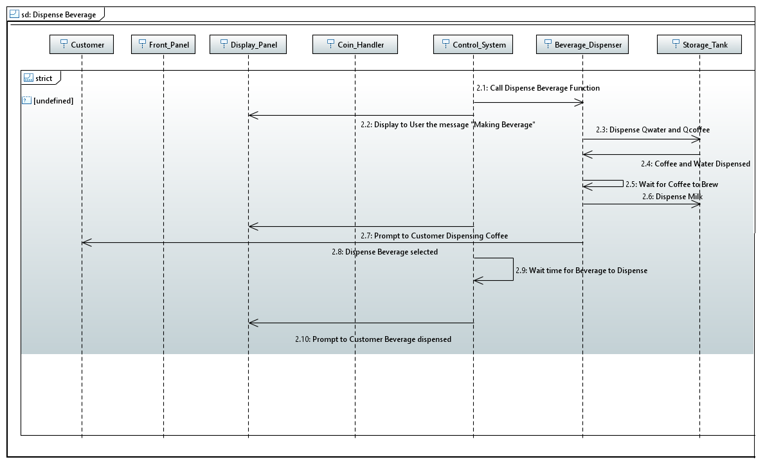

The above figure shows Dispense beverage sequence diagram. Once the control system identifies the user selection, a signal is send to beverage dispenser to make beverage. This is represented in the above sequence diagram. Once the beverage is selected by user, Coffee beans are ground by the grinder and moves to mixing chamber. Hot water flows from the boiler to mixing chamber where they stay some time for coffee to brew. The brewed coffee and milk are poured to the cup placed in front of machine alternatively so that they get mixed.

**c. Information Passed Between objects**

Once user inserts a coin, the information is passed between coin handler and control system. If coin is valid the credit for customer is stored else coin is dispensed back and status is send to control system.

The button user presses in front panel is send to the control system. It then identifies the beverage and sends the corresponding control signal to beverage dispenser to make beverage. Beverage dispenser communicates to between grinder, storage tank, boiler. It also monitors boiler temperature and send the value to control system.

Control system also sends regular messages to display panel to communicate with the customer.

**d. State Chart-**

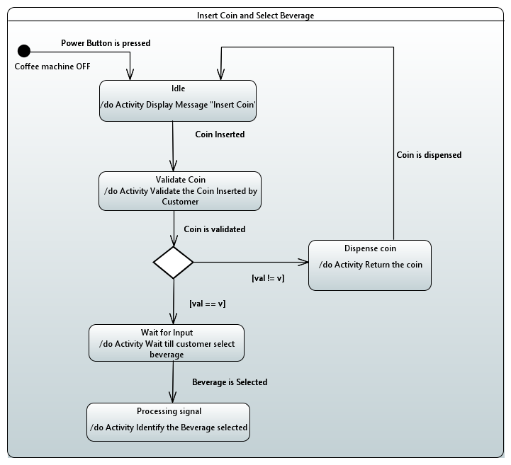

The State chart for use case insert coin and select beverage is shown above. Once user deposit coins in the machine, the sensor of coin handler will identify the coin inserted. If coin inserted is proper, the system will prompt the customer to select the beverage through display. User then selects the beverage he wants through the button at the front of the machine.

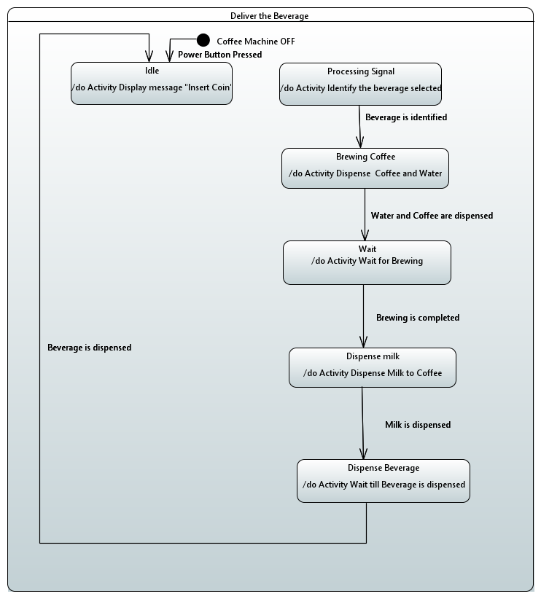

The above figure shows use case Dispense beverage’s state chart. Once the control system identifies the user selection, a signal is send to beverage dispenser to make beverage. This is represented in the above state chart. Once the beverage is selected by user, Coffee beans are ground by the grinder and moves to mixing chamber. Hot water flows from the boiler to mixing chamber where they stay some time for coffee to brew. The brewed coffee and milk are poured to the cup placed in front of machine alternatively so that they get mixed. We can see that Idle and Processing signal are existing states.

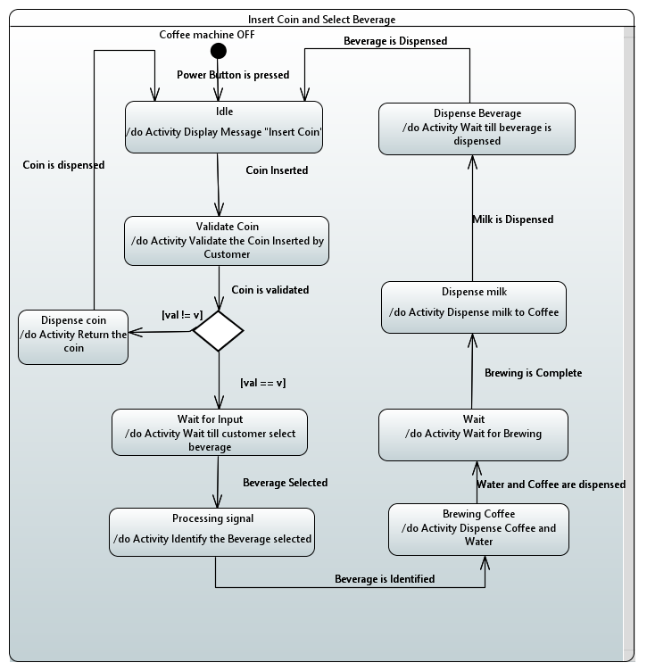

The above figure shows the combined state chart for both the use cases.

1. **Design Model**
   1. **Overall Software Architecture**
2. **SubSystems**

**Coin Collector Sub System**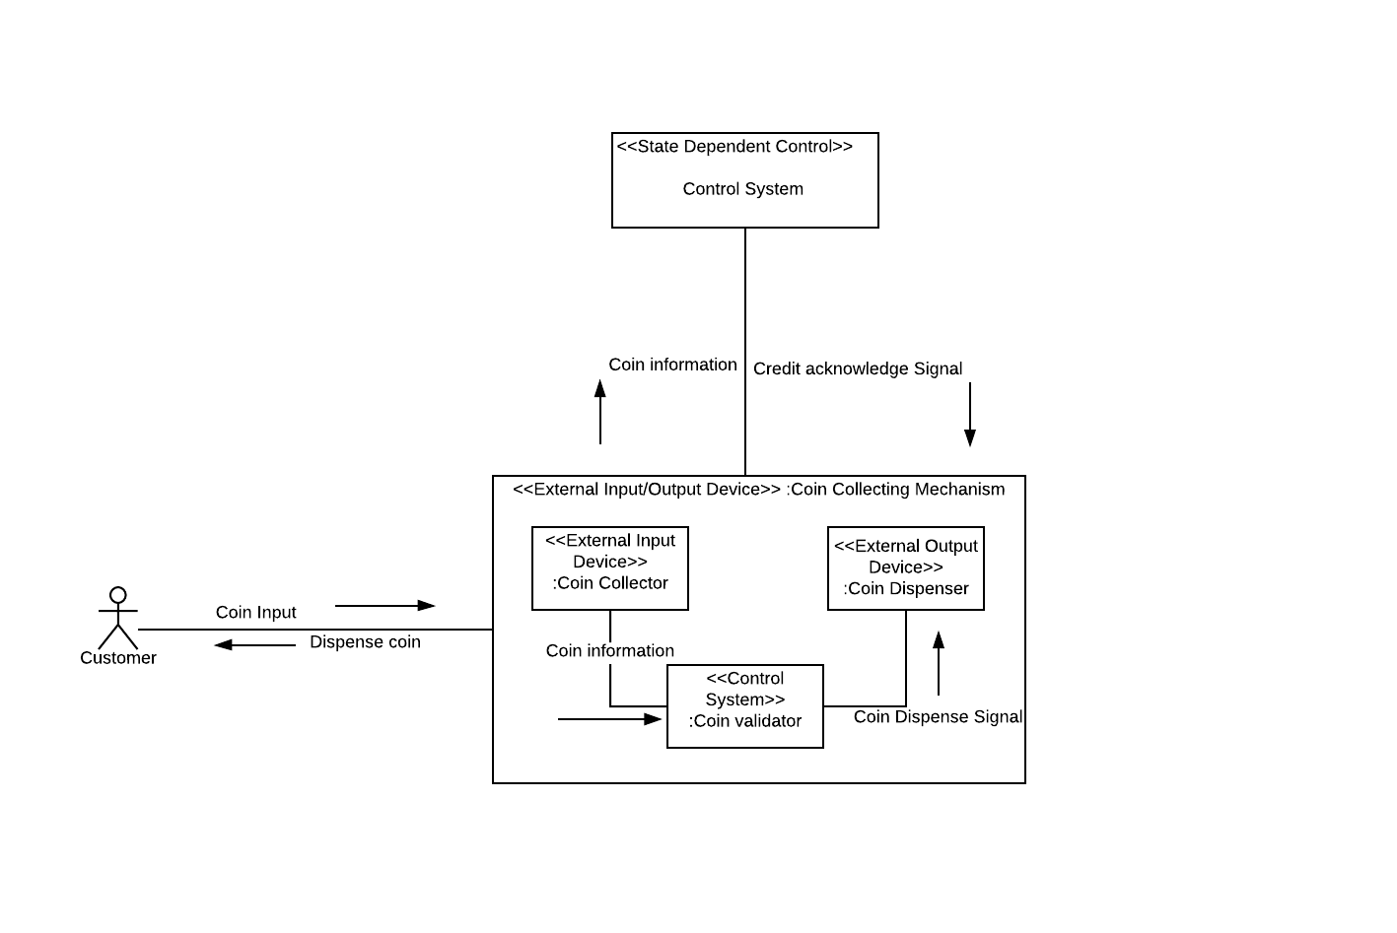

It helps to visualize the interaction between Customer, Coin handler and control system. In the coin handler subsystem there is coin collector to accept the coin, Coin validator to check whether the coin is valid and a coin dispenser to dispense the coins back to customer. They interact with control system to send the coin value.

**Beverage Dispenser Sub-System**

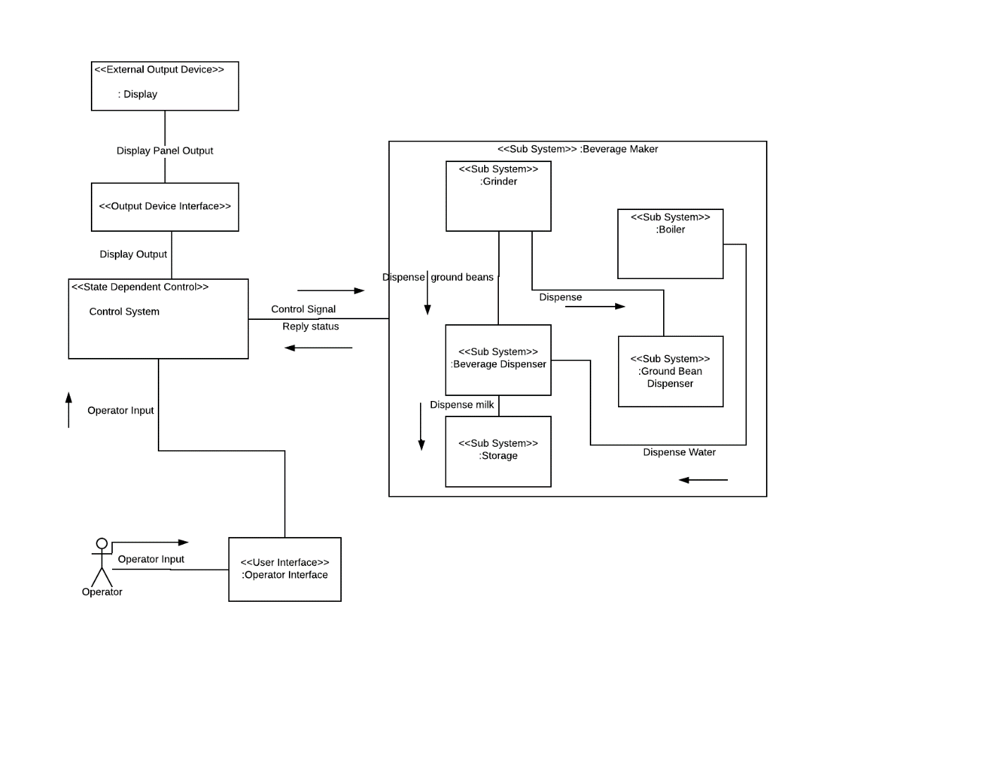

This subsystem takes care of dispensing beverage. It regularly interacts with the control system. It consists of a grinder to grind coffee beans, a boiler to boil water, storage tank to store milk, ground bean dispenser to dispense the used coffee and a beverage dispenser to dispense beverage to customer. Control system acts as the intermediate between customer and beverage dispenser to regulate communication.

1. **Interfaces**

Display Interface : To Interface between Display panel and Control System

Front Panel Interface: For connecting Front panel and Control System.

Coin Mechanism Interface : Interface to Enable Communication between Coin Handler equipment and Control System.

Customer Interface : The Interface between Customer and the Control System

Operator Interface : The Interface between Operator and the Control System

1. **High Level Structure Diagram and Low-Level Structure Diagram**

**High Level Structure Diagram** 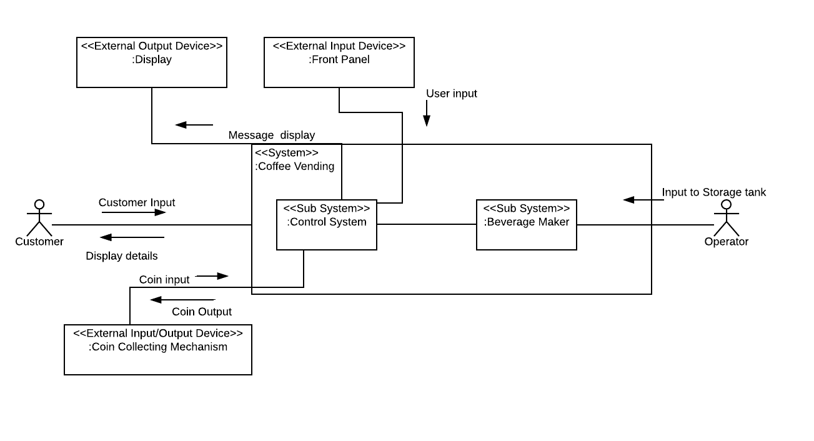

**Low-Level Structure Diagram**

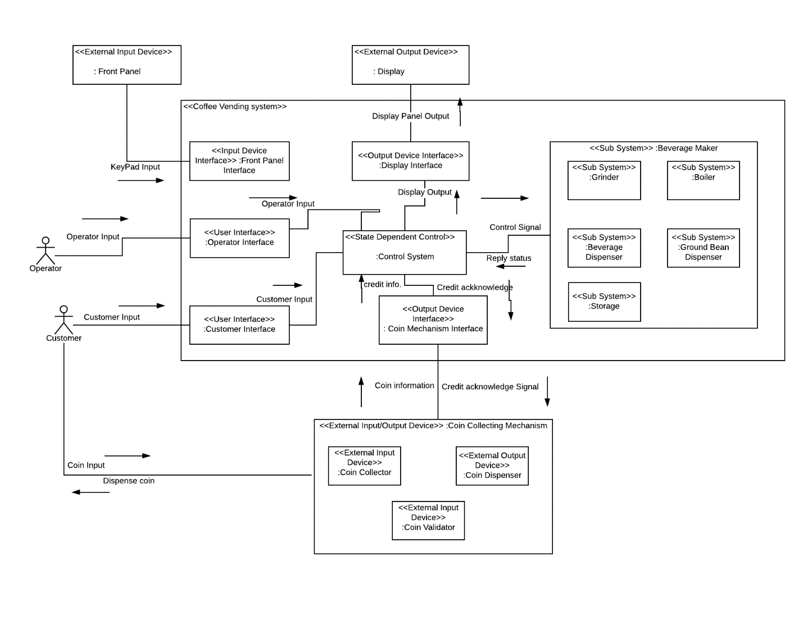

After adding the subsystems to high level structure diagram the behaviour of the system after adding the subsystems can be analyzed.

* 1. **Distributed software architecture**

1. **Distributed components and interfaces and Internal Concurrent Architecture**

As the Coffee Vending Machine is of closed environment type, it will not be possible to make the distributed component as. every component should be present together physically. So Distributed Component diagram and Interfaces and Internal Concurrent architecture is not developed.

1. **Deployment Diagram**

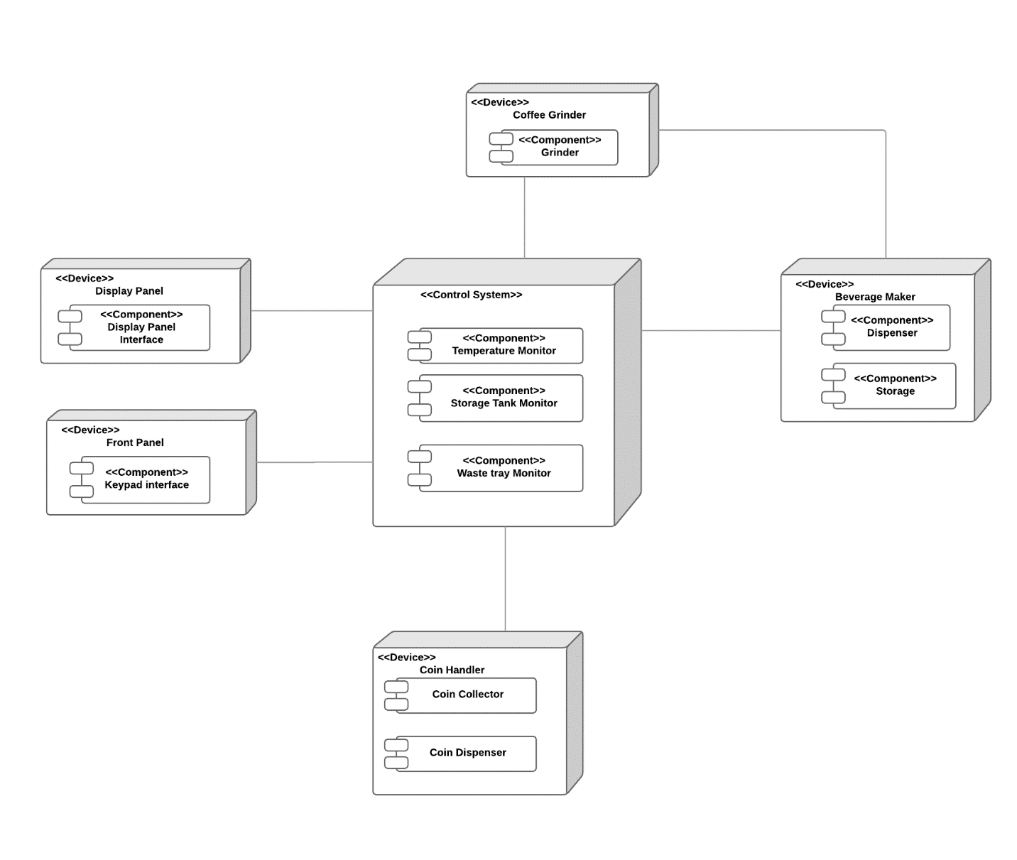

The deployment diagram shows the devices Front Panel, Display panel, Beverage maker, coin handler, coffee grinder and Control system. The interconnection between the components is also represented.

1. **Conclusion –**

COMET methodology was used design the different components of a coffee vending machine. The different part can be x`modelled as subsystem and deployment can be developed. It is easy to analyze the different use cases for coffee vending machine.